



MEETING OF THE CONGRESS COMMITTEE ON SOCIAL INCLUSION AND HUMAN DIGNITY
9 – 10 JUNE 202G KOUVOLA, FINLAND
DRAFT PROGRAMME 1
PRACTICAL INFORMATION 3

DRAFT PROGRAMME
- Arrival of members in Finland and at the Sokos Hotel Vaakuna
Monday 8 June 2026
- 19:00 – 22:30 Informal dinner at Pizzapaja Restaurant (at each member’s cost)
Tuesday 9 June 2026
- 08:45 Arrival at the City Hall (8 minutes walk from the hotel Sokos)
- 09:00 – 10:35 Committee meeting

- 10:35 – 11:00 Coffee break
- 11:00 – 12:40 Committee meeting (continued)
- 12:40 – 12:50 Committee group photo
- 12:50 – 14:15 Lunch at the City Hall (pre-reserved)

- 14:15 – 15:45 Committee meeting (continued)

- 15:45 – 16:00 Coffee break (time to be confirmed)
- 16:00 – 17:30 Committee meeting (continued)
- 17:30 – 19:00 Free time
- 19:00 – 23:00 Dinner offered by the Hosts (venue to be confirmed)

Wednesday 10 June 2026

- 10:00 – 15:00 Committee meeting (continued)
- 15:30 Departures from the Hotel for site visits
- 19:30 Return to the Hotel and departures to the airport

PRACTICAL INFORMATION
Transport

If arranging your own travel, please book the most economic flight options, arriving at Helsinki Airport. From Helsinki Airport, you will be able to take a direct train to Kouvola. The journey will take about 1h20.
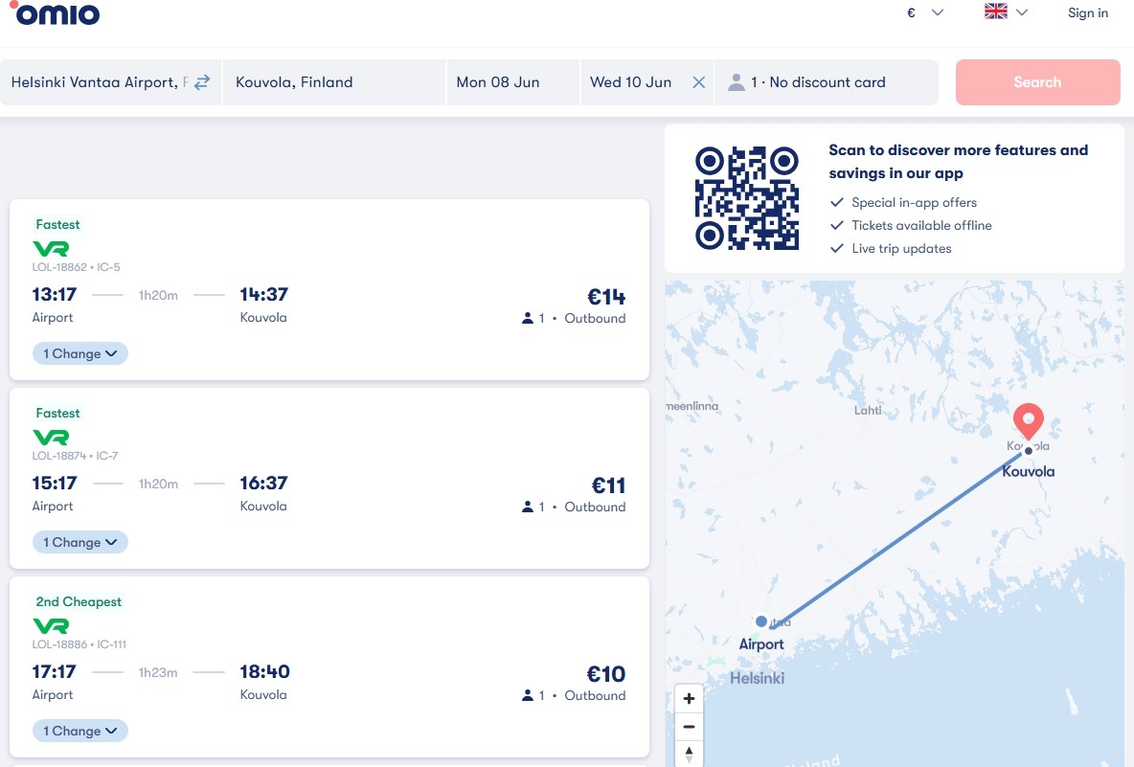

Once at the Kouvola train station it will take 12 minutes (800 meters) to reach the Sokos Hotel Vaakuna.
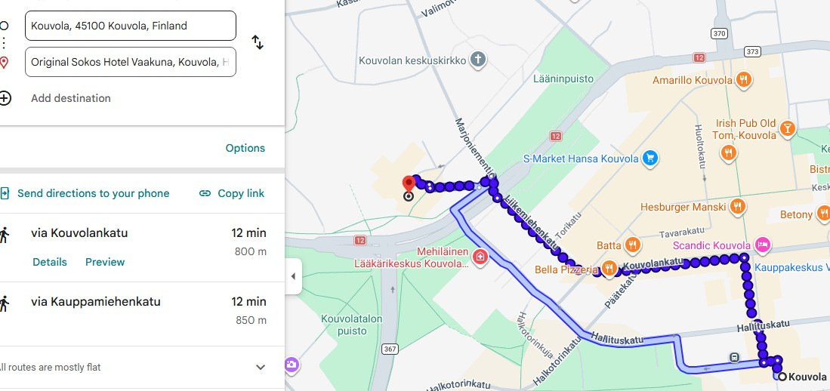

Accommodation
A special rate of 127 €/night/standard room and 147 €/night/standard twin room, breakfast included has been negotiated for the participants in Sokos Hotel Vaakuna hotels

The Social inclusion Committee meeting on 10 June will take place in Kouvola City Hall.
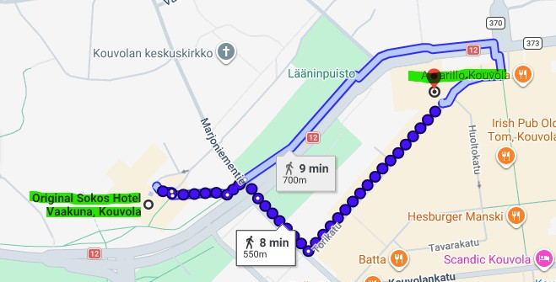

The Council of Europe will directly cover the accommodation fees for two nights (8 and 9 June ) for members registered to the meeting via Congress Connect.

Members registered to the meeting are asked to make their reservation directly with Sokos Hotel Vaakuna hotels and quote BSIC2026 to get the negotiated rate. They will be reimbursed after the meeting, according to the usual procedure. The hotel special prices will be prolongated for the 10th of June.
Original Sokos Hotel Vaakuna, Hovioikeudenkatu 2, 45100 Kouvola
E-mail: sales.kymenseutu@sok.fi
Book online at https://www.sokoshotels.fi/en/kouvola/sokos-hotel-vaakur Reservation need to be quaranteed by credit card.

Reservation can be also made directly to the hotel by email at reception.kouvola@sokoshotels.fi or by phone at
+358 10 7839101 or +358 10 7839 100. With the reservation code BSIC2026.

Contacts during the meeting

Congress Secretariat:

Ms Maren Lambrecht-Feigl, Secretary to the Committee on Social Inclusion, maren.lambrecht@coe.int) Mr Flamur Hamidi, Co-Secretary to the Committee on Social inclusion, flamur.hamidi@coe.int
Ms Pascale Jaffory, Assistant to the Committee on Social inclusion, pascale.jaffory@coe.int M XXXXXXXXXX, Assistant

Finish Association:

Ms Laura Parsama, Kuntaliitto, laura.parsama@kuntaliitto.fi Ms Paula Kosunen, Kuntaliitto, paula.kosunen@kuntaliitto.fi

City of Kouvola:

Kirsi Penttinen, kirsi.penttinen@kouvola.fi

