ERC Starting Grant 2021

Part B2

(not evaluated in Step 1)

Sections (a) and (b) of Part B2 should not exceed 14 pages. References do not count towards the page limits.

Section a. State-of-the-art and objectives

Research and Innovation in the EU

On December 10th, 2020, the European Commission (from here on EC) welcomed the political agreement, on 'Horizon Europe', a transnational collaboration with an investment fund of 95.5 billion. euro, thus expanding the most ambitious research and innovation program in the world (European Commission). It also introduced the European Innovation Council (from hereon EIC), as the intermediate tool to scale up research and new technologies (European Commission), with a total of 10 billion euro to be invested (European Commission). Our research proposal is in compliance with European Union’s (from here on EU) research policy, which has been activated under the new EU development strategy framework (2023-2027), and in continuity of previous policies such as the axe of ‘Future Emerging Technologies’ (from here on FET) in the subcategory related to Arts and Science (European Commission).

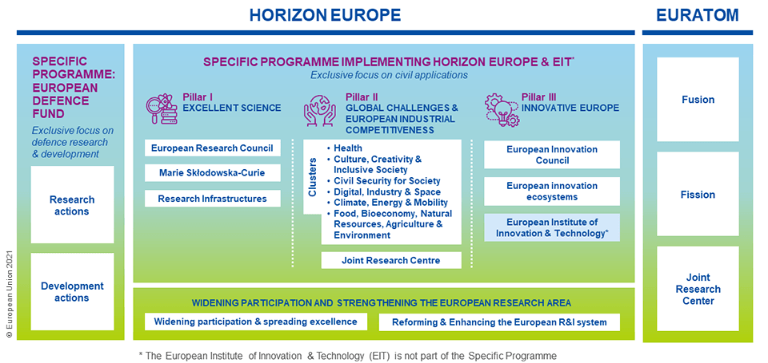

Within a five-year period, we wish to develop a fully portable system (software, hardware, high-end device, optic translators, crystal RAM processors) of holographic projections, which will allow users to interact with digital imprints on physical terrains, thus transform spaces into interconnectivity nodes, based on the interactions established among its users. As FET Open: the project highlights the radical technological shift that will result from the use of holographic, phygital environments. As F.E.T. Proactive: it seeks to create a critical mass of researchers in a promising interdisciplinary research. As a F.E.T. Flagship: the research could develop a potential for funding with millions of euros, as it will gradually bring together researchers to address the scientific and technological challenges of limiting accessibility and mobility, mainly due to environmental challenges (outbreaks of syndemics, stagnation of transportations and mass movement of climate refugees), as well as to establish new standards for the support of psychological resilience of Europe’s citizens, who in the past decade has faced multiple crisis (European Commission). Which leads us to conclude that the sooner this system is built and tested, the faster it will be able to spread to all member-states as a tool to adapt cities and populations to the new conditions (European Commission).

Economy

Our proposal is in line with the goals set by the EU for 2030, and more specifically for an economy that empowers people, through the acquisition of new skills, new employment models and business growth, thus responding to two of the key objectives of strategic planning (European Commission). On the one hand, the adaptation of populations to the effects of climate change (European Commission), on the other hand, the formation of cities as interconnection and interaction nodes, which will be based on activation technologies, to address humanitarian and social issues, such as racial diversity (European Commission), while securing EU’s leadership as a rising force in Culture, Lifelong Learning Development, and Knowledge Economy. This combination is fully aligned EU’s effort to become the first digitally activated circular, climate-neutral, and sustainable economy, but also a more resilient, inclusive, and democratic society. As the research will produce technological and engineering patents, as well as methodologies of appliance, we will seek to fill the financial gap in the early stages of our system development, and, as in similar cases in the past, this effort will require the available investment to remain active for a longer period of time (Bloomberg L.P.), thus we will address EIC for support. The project is expected to strengthen Greece's position in the European Innovation Scoreboard, in terms of intellectual property, employment growth in innovation-related sectors, and in terms of exporting high-tech products, covering a diverse range of design and functional applications (European Commission).
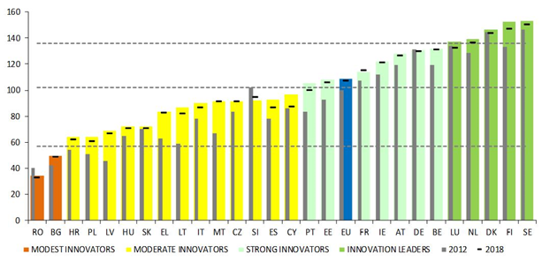
Greece ranks among the moderately innovative EU countries (European Commission)

The system will allow the architectural transformation of cities into interactivity nodes with their key features being the relations developed among populations within their limits. The system may be applied for: tourism, lifelong learning / capacity building / skill acquisition and education, creative industries, knowledge economy, cultural and natural heritage perseverance and significantly contribute to the sustainable development goals (European Commission). At the same time, it will contribute to the increase in costs and investments in the audio-visual sector, for the production of original works that will exist in the form of a digital library-repository of intellectual property, and each of them will be translated into both data and physical products through the technology of 3D holographic imprinting and/or projection. In this way we hope to increase the relative size of the country's economy, which is recorded quite low, in terms of their supply quota to Greece's GDP (OECD), reaching only 1.3% in R&D investment in technology and innovation. After all, a relevant recommendation to the country is recorded through a recent report of the Commission (Directorate-General for Research and Innovation).

The research protocols

Our research will answer the following problematics:

- How can we use architecture to build phygital, holographic, terrains that will highlight a new perception of the cities as interactivity nodes, focusing on the everchanging relationships between users (citizens)?
- How can we connect existing technologies (massive data storage and RAM processes based on crystals, digital optic translators etc.), and algorithms to achieve an interactive use of the phygital terrain for both the digital and physical imprints within the holographic projections?
- How can the system become fully operational (software-hardware-programming), selfsustained, perpetually accessible, and interactive in a way that won’t be threatening to human’s biological functions?
- How can this system be portable and fully independent in its functions, without producing new technological wastes, whilst avoiding constraints imposed by augmented or/and virtual reality tools?
- How can we connect the system with digital economy technologies (blockchain, phygi-wallet, Non-Fungible Tokens etc.)?
- Once the system becomes functional, how may the use of scenarios for Live Action Role Playing games, establish learning trajectories, through gamification of knowledge, improving the quality of life of its users?

Smart Cities as Interconnectivity Nodes

Haggett and Chorley (Hagget, P. & Chorley, R., J.) argue how networks are used in geography, focusing on the parallelism of cities as human systems and geomorphology as natural systems. Jacobs (Jacobs, J.), argues that we must consider that spatial position lies at the heart of how evolving networks of relationships provide the foundations that hold people together in cities, thus examining spatial positions as results of interaction. The question arising is “can modern architecture cope with the growing complexity of society, as a social, economic, political and cultural system?” Cities, can be perceived as a set of signs and features, captured according to the intensity, with which, some of their features are inscribed as more or less important to them. This forms a feature map, a record of a kinetic memory landscape as a set of points (places-properties) and connections. The minimum unit is defined as a place-property, with the degree of connection indicating the gravity with which some characteristics are meant in relation to others in the description of each place (Bozikas, P.). Respectively, natural and urban spaces may transform accordingly to the reinforcement of some characteristics and/or the number of elements-properties they are connected to (Bozikas, P.). Important to our research are Lynch's perceptual urban “imageability” (Lynch, K.), Rossi’s “urban factors” (Rossi, A.), Alexander’s “patterns” (Alexander, C. et al.) and the syntactic analysis of the “Space Syntax” method (Hillier, B.). Based on the theoretical background, we will investigate how our system will transform the designated areas from single points to network nodes, by analyzing simulations, structures and connections, to ensure optimal interventions. Our research attempts to change perceptions, which consider the urban fabric as a sum of spaces and/or points, in a process of highlighting the interactions that take place within residential and non-residential areas and, thus, we will try to establish processes of rearrangement and development of the form, based on the interactions and needs of the surrounding spaces and habitats. According to Lynch, we’ll evaluate urban form on the basis of the criterion of imageability, based on his proposed components of a city’s visual form perpetual image: identity, structure and meaning:

- identity: a utilitarian image requires first of all the identification of an object, which implies its distinction from other things, its recognition as a separate entity. This is called identity, not in the sense of equality with something else, but in the sense of individuality and unity.
- structure: the image must contain the spatial or schematic relation of the object to the observer and to other objects, and
- meaning: the object must have some meaning for the observer, whether practical or emotional. The meaning is also a relationship, but of a different nature from the spatial or schematic relationship.

Our focus regards five basic types of virtual elements, which refer to physical forms: paths, edges, districts, nodes and landmarks:

- paths: paths are channels along which the observer usually moves, cyclically or possibly. They can be roads, sidewalks, walkways, canals, railways. For many people it is the dominant elements of their images. the people observe the city as it moves through it and along these routes the other environmental elements are ordered and correlated,
- edges: linear elements that are not used and are not perceived as paths by the observer. They are boundaries between two phases, linear breaks of continuity: shores, railway breaks, configuration boundaries, walls. They are more oblique references than coordinate axes. The edges may be barriers, more or less permeable, enclosing one area relative to another, or they may be seams, lines along which two areas are interconnected and joined. The elements of the edges, although probably not as dominant as the marches, are for many important organizational features, especially in terms of their role but hold together generalized areas, such as the outline of a city by water or walls.
- districts: medium or large parts of the city, perceived as two-dimensional areas, to which the observer "enters", and which are recognized as having a common, identifiable character. Recognizable from within, they are also used as external references, seen from the outside,
- nodes: strategic places in a city that the observer can enter, and which are the intensive focal points to and from which he travels. They can be mainly road junctions, places of transport interruptions, intersections or convergences of paths, moments of transition from one structure to another. Or it may be simply concentrations, which derive their meaning from the fact that they are of some use or of a natural nature, such as an enclosed square. Some of these hubs may be the focal point and the epitome of an area on which it radiates and for which they are symbols, and
- landmarks: another type of reference point, but in this case the observer does not enter them, they are external. It is usually a simply defined physical object: building, brand, shop, mountain. Using them involves isolating an element from a host of possibilities. They are often used as elements of identity or structure.

These elements are the raw material of the city-wide environmental image, that intertwine and co-shape its image, while the types are open and interchangeable, so that the structure can be interpreted as belonging to different types, depending on the point of view and the frame of reference in which it is observed. In our view, Lynch’s approach can be applied to both an already structured sum of elements (city) and an unstructured sum of elements (stream, mountain peak, slope, hill shape) of the natural environment, which can undergo a similar analysis. This analysis will be based on the theory of urban factors, as elements of the urban fabric that show unity, individuality, and duration and play an important role in shaping the perceptual image of an area and empirical recognition of its identity. Alexander’s patterns (Alexander, C. et al.), will be combined, to determine which of them “summarize a property common to all possible ways of solving a problem”. Hillier’s “Space Syntax” (Hillier, B.) will help us identify pattern aspects, regularities and repetitive structures, focusing on the examination of space as a system of correlations. It will provide tools for describing and quantifying non-dialectical, ordinal spatial properties, creating models for comparative spatial analysis based on multiple properties, and identifying regularities and repetitive standard relationship structures for rendering indescribable characteristics that cannot be approached on other terms (e.g. social interactivity). Bafna’s (Bafna, S. et al.) accessibility relationships between elements of a spatial arrangement, will be linked to the social situation they host and help us draw conclusions about how different spatial provisions allow-guide specific behaviours and phenomena. For the representation of multiple superimposed levels, we will try to find what the independent levels are and how they are interconnected. This will help us categorize-standardize spatial qualities, and process them as network nodes calculating their influence on the system. Due to the non-linearity of the interactions, the overall evolution of the system is largely unpredictable and uncontrollable, but the system tends to self-organize, in the sense that local interactions ultimately produce overall coordination and synergy. Complex, self-organized networks usually exhibit grouping properties, without scale, and form a microcosm, while retaining features (flexibility and autonomy) as aspects of their self-organizing process to deal with internal and external disturbances. This allows them to evolve and adapt to an ever-changing environment. When dealing with such complexity we’ll adopt Ashby’s, modern version, ‘Theory of complexity’ (Conant, R.), as we’ll conduct mathematical analysis of nonlinear dynamics and chaos to investigate the systems complexity, to identify networks in which populations interact through various correlations (Batty, M.). As we are going to set up a network of interventions, we must keep in mind that this will function as an information structure, the content of which will potentially be expressed both materially and spatially, consisting of multiple building blocks that retain their autonomy (individual identity and behaviour), but interact closely with each other (Terzidis, K.). As networks are characterized by nodes (interacting variables), while their characteristic is the interaction with the environment to which they belong, from which they are able to receive information and perform. Thus, in agreement with Terzidis (Terzidis, K.), through complexity we will identify the amount of time required to create our system. A necessary condition in this direction is to introduce the term ‘probability’, as it plays a centripetal role in the process of simulating complex systems as networks. Probability as a factor, in the context of computer design, will be used to represent the variation that would show natural results in the real world. The control of the set is replaced by the control of the nodes of the set - or otherwise interdependent elements - which regulate and control local parameters. The solution of the node is more related to the design and control of a space of possibilities - field, in which really innovative results will emerge. A key feature of our approach is the constant redesign from scratch, with results that we are not able to know in advance. These results will be examined in the light of the philosophical concepts that Delanda identifies in Deleuze's “Assemblage theory”: population, intensive and topological logic (Delanda, M.):

- Population logic: makes the individual unit as part of the whole, a population of distinct uniqueness which co-shape its characteristics. It is related to the categorical logic, which refers to the spatial - intangible boundaries of the distinct entity (Parmenidis, G. & Charalampidou-Divani, S.). The scope of unit delimitation possibilities is the population and individuals are manifolds that recommend converging and divergent series of variants (Buchanan, I. & Lambert, G. edts.). The same is true of structures, where a multitude of forms will be able to inherit different characteristics and the next generations will enjoy significant differences between them.
- Intensive logic: deals with the processes that produce the things around us. The modern definition of intensive quantities or otherwise intensive variables is given as the opposite of expansive quantities or variables. Intensive (temperature, humidity, pressure) variables are defined as those which are independent of the quantity (mass, volume) of the system components, while as expansive (length, area) those which depend on the quantity of system components and have an additive character. Intensive differences are productive differences in the sense that the processes that are activated are those that produce a variety of forms. Intensive logic refers to the possibility of displaying and simulating dynamic behaviour and in this sense is related to the procedural logic of approaching the closed - open limits of meaning of entities (Parmenidis, G. & Charalampidou-Divani, S.).
- Topological logic: refers to the correlations between the parts of a system and the possibility of configuring them in such a way as to describe a “common plan” (Delanda, M.), an abstract general plan that by applying different “intensive operations” leads to different snapshots. This abstract diagram is a description of a class or parametric model, which delimits the field of possibilities from which specific multiples or snapshots can be selected, activated and realized. The plan "must be abstract enough to be compatible with different combinations of expansive quantities" (Delanda, M.). The transition from one instant to another is possible through topological transformations, which are defined by the abstract diagram as potential multiplicity. Topological logic, referring to the possibility of transformation from one uniqueness to another through the functional expression of a parametric model, is related to functional thinking and the continuous - blurred boundaries between entities. In topology the issue is the description of the space itself, taking into account the invariance of the object (Parmenidis, G. & Charalampidou-Divani, S.).

To be able to architecturally calculate the use of algorithms, we will create the appropriate “spaces of possibilities”, which will feed the potential, phygital, evolution. In agreement with Riemann (Baker, R., Christenson, C. & Orde, H, edts.) we will introduce a set of numbers for each point in space that we will describe (10 numbers in each point, in a total of 4 spatial dimensions), in order to be able to describe the properties of multidimensional manifolds (metric tensor) in 3D surfaces. In this way we will try to correlate the intensive and topological thinking, placing in each of the dimensions of the surface a different intensive quantity, thus creating a "phase space". Thus, we will identify the “dimensionality” of the systems under study, regardless of whether their surfaces are folded, stretched or distorted and apply the holographic projections on these surfaces. By attempting to capture and represent successive states in time, we will create the representative trajectory to assess whether and to what extent our system will acquire the dynamics of a state loop - periodic attractor based on material changes (phase transitions), with the aim of achieving symmetry-breaking transition, mainly on the basis of the transition from quantity to quality. This approach is necessary as we want to create a wide space of possibilities, which will feed the evolutionary process and which in turn will make the use of algorithms an essential tool in our hands. The question is how can the imperishable be formed into a process, the result of which is something stylized and feasible? The answer to the question is topology (Delanda, M.), as it deals with the continuity of transformation. It includes the forms within their own variation, of which each point can be a possible feasible form (local manifestation). The shift to topology implies a shift to the very object of the architectural design process. The form follows the design process and the principle for the architectural construction will be the change of form (deformation). This means that the identity of things is synthesized or created as a piece of cosmological, geological, biological, or social history. Assemblage theory also allows us to research concepts such as network, locality, multiplicity, uniqueness, and many others which seem to influence not only modern design trends but also socio-economic ones. To achieve the synthesis of algorithms for the integration of digital traces in natural or artificial environments, we will use double articulation, through which we will establish hierarchical layers (strata) or self-consistent aggregates, a process which will reveal how the end result will be superior in value, size and complexity from each level. The final product will be the result of the parallel process of:

- The first articulation (plane of content) concerns the parts (substances) that will be selected to form the basis of creation or organization.
- The second articulation (plane of expression) will create fixed forms, through which we will lead the forms to the actual existence (actualization).

To this extent we will focus on the multiple functionalities of the system and the possibility of exchanging its digital parts, to identify the independent elements that can be detached and reconnected to operate in the same or different way. The reason is that we will try to investigate how relations of interiority develop between digital traces and physical forms. This will help to establish relationships and interactions between the parties, so that the interactions can be modified without changing the relationships. As urban design begins to focus on developing systems that are open and evolving over time, which will consist of elements interacting with each other, it increasingly tends to incorporate assembly theory, given the complexity it is able to manage modern digital tools. Organizational principle of this new space is movement, as new technologies in the design process are called upon to manage the flow, change and instability that occurs given the flexibility and multiple alternative relationships that may arise. That is why we will attempt an approach to the ontology of space, which will allow us to recognize the huge range of information dimensions, and their contraction (flatten), in a perceptual context. The development of relationships on a horizontal rather than a hierarchical level will allow us to realize whether through holographic projection and representation we can achieve the creation of a space that is to receive active objects-elements, the control of which will then lead to possible architectural objects, as in recent years cities tend to be perceived, architecturally, as a system of long-term dynamic development and evolution. Effective intervention and small gradual planning can lead to large and effective changes that take place with the flow and do not fight the tissue. In conclusion, the information age highlights a wide range of parameters that similarly influence the way we understand the city, through a spatial science that seeks to take into account areas of social interaction, economics, politics, to serve the needs of society at the design level (Directorate-General for Research and Innovation).

Phygital environments and mixed realities

The ever-increasing dynamics of the correlation of physical and digital elements, has led to interventions that tend to combine the two features to produce a new, more complex and more integrated system, which has as its dominant component the ability to deconstruct and recompose its data in multiple ways (Chatzidamianos, M.). One of the technologies that allows digital elements to be integrated in natural environments, producing results of increased spatial perception is augmented reality (Hofmann, S.), as it allows the users to perceive mainly visually the totality of structures, as in the case of Odiham Castle. As presented in the picture below, a glass depicting the damaged parts of the building was put on site, allowing visitors to visually perceive it as a whole through a graphic representation. Additional ways to enhance a physical space with digital data are, among other, QR codes, and/or the placement of mobile storage devices, where users can connect and access data, stored on site. Nonetheless, when combining digital and physical elements, they are rarely linked into a single unity.
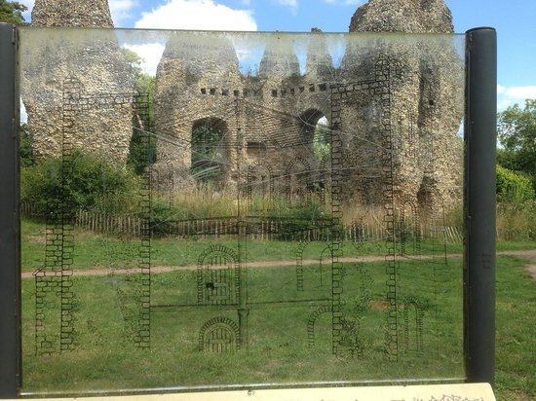
Picture 1. Enhanced perception intermediate tool in Odiham Castle, North Wormborough.

In 2011, a knowledge broker introduced the term phygital (Chatzidamianos, M.) to describe in a theoretical context the possibility of embedding digital imprints on physical surfaces, in a way that the digital elements will interact both with users and the natural environment, without altering the latter. The term has been widely used since 2013, as the Australian company Momentum patented it to describe the inseparable connections between the physical and the digital world (Weil, C.), rather than explaining how these two merges to create a phygital one. Indicative of the different approach are the following images, where on the left we see an appliance of Weil’s approach and on the right, we see an appliance as Chatzidamianos suggested.
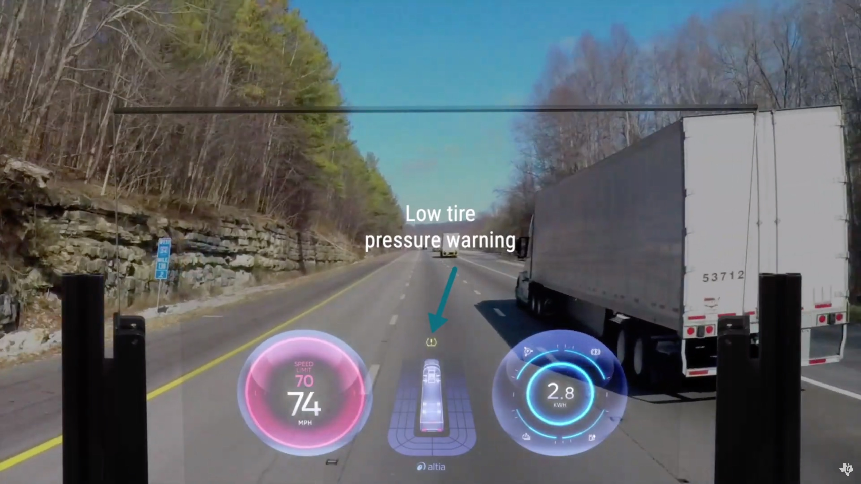
Picture2: On the left phygital technology is applied as perceived by Weil, on the right is applied at Lockwood Gardens, as perceived by Chatzidamianos.

In the first case, the digital imprint is not connected to the physical terrain (road), while in the second the digital imprint is adapted on each and every element of the physical terrain (projections based on the species of plants). In the first case the structural form (road) is considered as a non-variable condition, while in the second, the new structural form is based on the variability of conditions (temperature, humidity etc.), thus space is perceived as “living system” undergoing constant changes. In the same way, cities may be perceived as nodes of perpetual change because of the multiple, interactions taking place in them (social, economic, etc.), as well as the natural phenomena (variable conditions) (Directorate-General for Research and Innovation).

Holographic technology, the next niche market with an answer on bioethics problematics of AR and VR

Chen, alongside a team of five researcher (Chen, Y. et al.), reported that Augmented and Virtual Reality technology (from here on AR & VR) does not take into account the human factor (optic nerve and cerebral cortex) in terms of 3D depth perception, as the response of human vision tends to be different from stereotypical images of the real world, as they are perceived by the macula, located in the centre of the retina and allowing the human brain to recognize the images. In general eye use, macular degeneration is less important for a wide field of view. However, the macula receives extremely intense photochromic variations, at a very close distance from the eyes, and at the same time increased temperature (depending on the intensity of the light and the device) in AR & VR condition, resulting in the response of the macula command (reception of bright blue light for a long time), the contraction of the radial muscles to take the form of a spasm, which in turn causes eye strain, pseudo myopia and / or digital myopia. According to the researchers, the normal measurement index for visual response should be developed and standardized in order to improve image capture in AR & VR in the future. Already, many users of virtual reality technology are complaining of eye pain, headaches and, in some cases, nausea. Experts say this is due to the way VR affects the eye-brain connection. So, while in real life, our eyes naturally converge and focus on one point in space and our brain is so accustomed to what connects the two responses together. VR separates them, confusing the brain, a phenomenon that scientists have called the "vergence-accommodation conflict" (Gotsis, M.), which is caused by the deception of the human brain, without knowing the long-term consequences of the phenomenon, and the same applies in relation to the functionality of the acoustic system (Gotsis, M.). A similar problem is found in the operation of the audio resource, as the increasing volume used in virtual technology devices, on the one hand can cause greater immersion of users in the imaginary world, but in the long run, “the increasingly loud "It sounds normal, but it can really damage your hearing” one can read the Sony PlayStation package (SONY Interactive Entertaintment LLC), urging users to turn down the volume if they find they can't hear people talking around while playing. In addition, most devices include pre-use medical warnings as users may have pre-existing conditions such as, but not limited to, visual abnormalities, psychiatric disorders, heart disease or other serious medical conditions. The warning includes implanted medical devices (pacemakers, hearing aids, and defibrillators), and patients with epilepsy or a history of seizures. Manufacturers advise users to be especially careful of involuntary muscle contractions and loss of balance as a sign of a possible problem. Daydream View (Google LLC) warns that sharing the device could be a source of contagious diseases and skin infections. Another problem is that the use of virtual reality devices primarily forces users to cut themselves off from the natural environment around which they tend to lose touch, as they perceive only digital content. "While wearing the product headset, you are blind to the world around you," says the HTC's Vive (HTC) safety information page. Facebook's Oculus Rift (Facebook LLC) includes an infographic with the product and features an online safety centre with video explanations to illustrate security issues. Furthermore, it becomes clear that it is impossible to use VR without complications for the users, based on two different factors. The first concerns the energy efficiency of the devices, and the second raises several bioethics concerns in relation to the health and safety of users. In trying to summarize the reflection on the moral threats that arise for the individual, it is important to refer to at least nine of them:

- User protection: Users are required to bring some form of physical protection, depending on the nature of the proxy device, as users may end up not recognizing the key hazards in their immediate environment.
- Isolation of users and social consequences: It is already being found that excessive use of technology can cause physical addiction. Although rare, some people are consumed by both social media and / or video games isolated from society to an unhealthy degree.
- Pornographic content: There are already indications that excessive exposure to pornography could affect harmful behavior towards women. If users interact with pornographic content in an even more realistic environment, with a style of first-person interaction, what effect could this have on violent crime? The problem becomes even more complicated when the ability to simulate interactions with real-world people or the possibility of fake sexual acts that are illegal in the real world is introduced.
- Cybercrime: Speaking of crime, how do we manage to commit crimes in a virtual world? Today's video game culture is separated from the veil of the screen and the control to control a character. So what if users replace this mediation with e.g. realistic execution of a stabbing move or pulling the trigger in a super-realistic environment.
- Real applications: After spending too much time in a virtual environment, it can be difficult for users to get back to the real world and behave the same way they did before the virtual experience. They may be desensitized to certain types of violence or interactions, which could damage their social relationships. They can also overestimate their physical abilities, make a leap they can not make, or try a skill they have only perfected in a virtual reality environment.
- Trauma in play: You may not need to experience an event in physical reality to experience the effects of Post-Traumatic Stress Disorder (PTSD). For games that require tough moral decisions or experiences that simulate a painful ordeal, participants may be forced to face permanent psychological consequences.
- VR as torture: What if you could hurt someone in a virtual environment? Would it be considered torture? The answer is not black and white, but it is a question we need to explore - and which is already being asked by philosophers of technology. Military personnel may view VR as a kind of moral alternative to torture, putting people in horrific experiences without ever causing bodily harm.
- Virtual Travel: VR could help people explore the world, visit countries and locations they would never otherwise be able to do. But what about places that restrict visitors (eg for reasons of religiosity)? Or to put it even more simply, is it ethical to allow a user to digitally "visit" the apartment of a former relationship? What kind of limits are we going to impose for virtual travel?
- User privacy: As with most new technologies, we must also consider user privacy. Users will be able to take more action and interact with more types of content than ever before, engaging in behaviors that they can avoid in the real world. Who is responsible for ensuring the privacy of users and how could this data be used?users protection, isolation of users and social consequences, pornographic content, cybercrime, real applications, trauma in play, VR as torture, virtual travel, and user privacy (McEvoy, F., J.), (Behr, K., M. et al.), (Bird, E. et al).

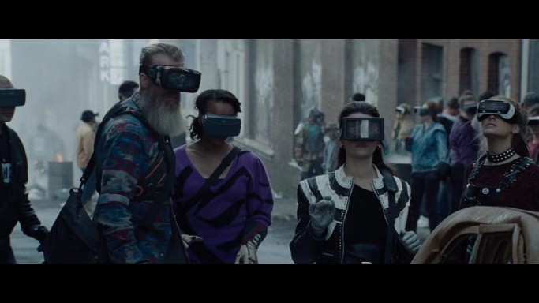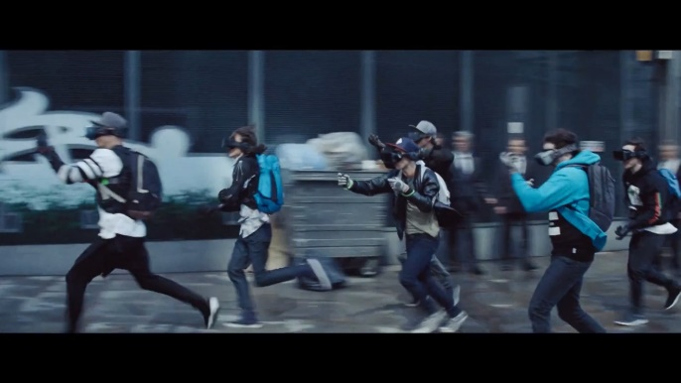
Images from the movie “Ready Player One”, in which VR becomes mainstream culture

To avoid these bioethical questions and in an effort to overcome the health threats from using VR and AR intermediates, we propose the usage of holographic projections, as this technology is the new frontier that will change the way we interact both in the physical and digital world. It will have a huge impact on all areas of life, including business, education, science, the arts and healthcare. Holography is the method we use to record light patterns and it was discovered in 1947 by Dennis Gabor (Wikipedia). These patterns are reproduced as a three-dimensional image called a hologram (El Baze, E.)

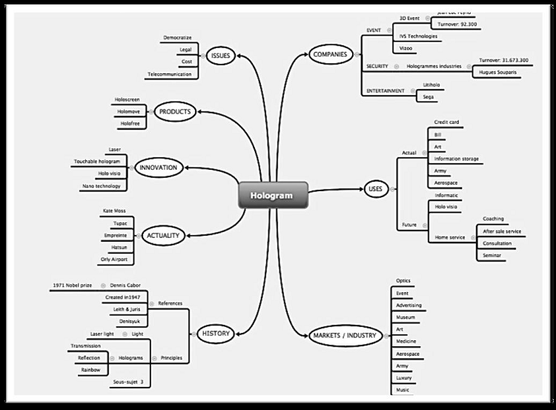
EL Baze’s figure describing the benefits of the holographic projection usage

Thanks to HD technology and CGI technology, holographic 3D projection has transformed into a futuristic audio-visual mediation already used by major companies, thus introducing a niche market (El Baze, E.), already being exploited by companies such as Endemol, BMW, Korean audio-visual Commission, etc. yet allowing emerging stakeholders to move as quickly as possible to invest in its development. Less than a month ago two companies announced they are entering the holographic projections market with their new projects, that is Microsoft’s MESH and PORTL’s Epic Holo Protl, thus proofing that our proposal is one step ahead, as both companies realize that this emerging tech trend will not be easily purchased due to its high cost (Bates-Ramirez, V.) in contradiction to our system. Another difference lies with the fact that both companies are working on stationary projectors and not on a mobile one, as our research protocol suggest. We strongly believe that the support for the development of our system will allow us to be one step ahead of the companies as we want the project to result from researchers of various disciplines from across the EU.

The superman crystal and its appliance in our system.

5D Optical Data Storage (sometimes known as Superman Memory Crystal is a nanostructured glass for permanent digital data recording using a femtosecond laser writing process. The memory crystal can store 360 terabytes of data for billions of years. The idea was tested experimentally in 2013 (University of Soutampton). The idea is for mass storage of optically data on non-photosensitive transparent materials, such as fused quartz, which is renowned for its high chemical stability and strength. Enrollment in these materials using a femtosecond laser was first proposed and demonstrated in 1996. Storage media consists of fused quartz where spatial dimensions, intensity, polarization and wavelength are used to form data. By introducing gold or silver nanoparticles embedded in the material, their imaginary properties can be utilized. To date, up to 18 levels have been tested using optimized parameters with a pulse energy of 0.2 microjoules (5.6 × 10×14 kWh), a duration of 600 fs and a repetition rate of 500 kHz. Assuming a 100% efficient laser, ie a watt-hour (3.6 kJ) power consumption for a maximum data storage of 0.5 Mbits. For 1000 Mbits storage that adds up to two kilowatt hours (7.2MJ). Durability testing using accelerated aging measurements shows that the nanodegradation decomposition time is 3 × 1020 ± 1 years at room temperature - 30 ° C (86 ° F). At an elevated temperature of 189 ° C (372 ° F), the extended decay time is comparable to the age of the Universe (13.8 × 109 years). By recording data with a numerical target of 1.4 NA and a wavelength of 250-350 nanometers (9.8 × 10−6-1,38 × 10−5 in), a capacity of 360 terabytes can be achieved. This new method of data storage is called the "5-dimensional" method. This is more for marketing purposes, as the device has 3 physical dimensions and has no higher dimensional exotic properties. According to the University of Southampton:

- 5-dimensional disks [have] tiny patterns printed in 3 layers inside the disks. Depending on the angle from which they are projected, these patterns may look completely different. This may sound like science fiction, but it’s basically a really fancy visual illusion. In this case, the 5 dimensions inside the disks are the size and orientation in relation to the three-dimensional position of the nanostructures. The concept of 5-dimensional existence means that a disk has many different images depending on the angle from which it is viewed and the magnification of the microscope used to project it. Basically, each disk has multiple levels of images at the micro and macro level (University of Soutampton).

This processing and storage technology were first researched in 2010 by Kazuyuki Hirao, at the Kyoto University, and later developed by Peter Kazansky, at the Research Centre of Optoelectronics, of the Southampton University (Kazansky, P. et al.). As early as 2017, companies such as Hitachi and Microsoft have researched and developed 5D optical storage techniques, such as the fractal/holographic data storage (AUTH). Nevertheless, companies haven’t announced research and development of this technology for the creative industries sector, rather than an effort to operate it in data transfer from generation to generation, to reduce business operating costs (Microsoft Corp.). This fact allows us to think that we may achieve a system mainly dedicated to be used in the creative industries economy, as from 2018, the Universities of South Australia / Adelaide and New South Wales, are collaborating on storage devices based on salt crystals, thus showcasing it is the optimal time for us engage with the development of such a device for particular usage, under the light of this research protocol and the technology of Femtosecond lasers (UNISA).

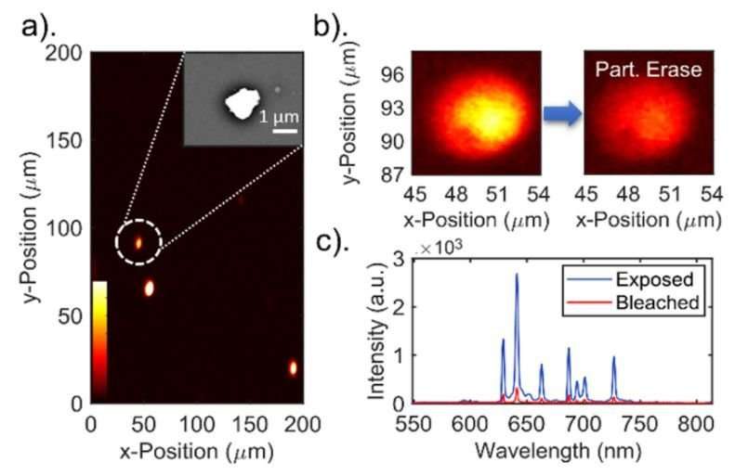
Image from the study of researchers from the three universities of Australia, in 2018.

In 2019 the Aristotelian University of Thessaloniki, Greece, also announced findings on this research field (AUTH). More specifically, the Research Team of Wireless and Photon Systems and Networks ERAFOS replaced the electronic memory with a corresponding random-access RAM circuit, which supports read and write speeds of 10Gb / s digits per second), achieving twice the speed of the fastest electronic RAMs made by world-renowned IT companies such as Intel and IBM. The study was published in the prestigious journal Optics Letters, one of the largest scientific journals in optical technologies. The team thus managed to overcome a long-standing computer problem, also known as the "Memory Wall" (AUTH). According to this, the speeds of random-access RAMs increase for more than 30 years at a much slower rate than the corresponding processor speeds, resulting in an ever-increasing gap between the performance of processors and RAMs, as the processor will have to "wait" to receive data from slow memory, so it cannot process it quickly and delay other processes. The "heart" of optical RAM consists of fast optical switches, the equivalent of electronic transistors in photon technology, interconnected in a standard two-state optical device, "0" and "1", while a third optical switch controls whether the Read or Write to memory function is performed. As light cannot be "trapped" spatially and therefore stored as easily as electrons and electronic memories, the research team implemented a technique that utilizes two interdependent but different wavelengths: when the one wavelength dominates within the proposed device-memory, then forces the other to remain off, so by assigning the digits 1 and 0 to the two different wavelengths digital storage is achieved.

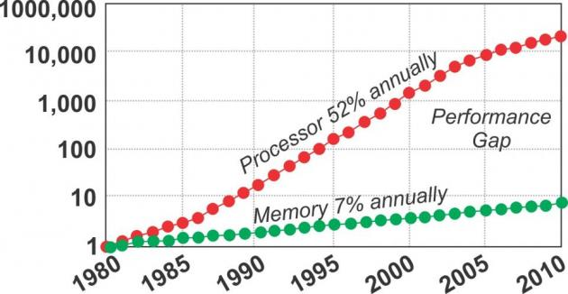
Picture of the graph of the results achieved by ERAFOS of AUTh in 2019.

It is understood that this technology is expected to gain increasing business penetration immediately and on a large scale, as the use of data storage devices is constantly increasing, and especially on a practical level for the management of big & mega data, as they are gathered by the plethora of users in global level. We expect to sign a memorandum of collaboration with the organization when entering the phase of development of this part of the system, to be integrated as a solution regarding the amount of big and mega data process and storage, as they will be gathered from users and stakeholders, especially when realizing that this might develop as a spinoff protentional venture, to the main research target (AUTH). Our goal is to integrate this technology into a mobile device and to connect it to the rest of the system, through the use of algorithms.

The necessity for an optical translator

As realized from the previous section, for the system to be fully undependable and, at the same time, to minimize possible implications in relation to human anatomy, we identified a necessity to develop a wearable optic translator, which will reduce the harmful effects that VR has imposed to the optic, motion and acoustic system of the users. This technology is already under the R&D microscope of major companies around the globe. As of 2020, the Spanish automobile company, SEAT’s smart quality department, has been developing their “Eye-tracker” smart glasses with infrared sensors, high resolution cameras and an advanced algorithm, to record everything drivers looks at, as well as their reactions, with an aim to accurately collect data while driving, to see what people notice and how they behave when driving, in order to improve safety levels (Papalampros, L.). To take this technology to the next level, we will take advantage of research such as the 3D printed cornea from human cells (Becker, R.), the bionic eye which merged contact lenses with QLeds (Starr, M.), the Gunnar 3DTM research protocol (TEC), Princeton University’s five layered, 3d printed contact lens (Griffiths, S.), as well as other existing technologies and patents like the ones from Sony and Samsung (Inverse), (Buhr, S.), applying reverse engineering when possible, but also by inviting some of these researchers to join our team and combine their technology towards a new developmental prospect. Summarizing the aforementioned technologies to be combined in our system, we will follow Cyrino’s state of the art example (Cyrino, G. et al.), as described in their work “An Interactive Holographic Environment for visualization of heart structure and activity”. Driven by the applications that holographic projection technology can have for the medical industry, Cyrino et al. argue that when introducing researches based on the development of interactive holographic environments, they should incorporate: advanced interface, architectural composition, mixed reality and computational holography tools, portable holographic projectors, creation of interactive 3D models, and the best possible visualization of information, which have been described as core parts of our effort to achieve a successful and ready to use system.

Cultural and technological cohesion

In the recent decades we’ve seen tremendous changes taking place in every aspect of living expression, due to the rising of technological leaps, as resulted from long term researches. Although those technological achievements should narrow the gap of inequality, not only they didn’t manage to do so, rather than – as reflected in a recent study (Kharlamova, G., Stavytskyy, A., & Zarotiadis, G.): Central European countries and the UK have reached such a level of development and redistribution in the economy that a change in labor productivity is not significantly associated with any deepening of inequality in incomes. Periphery countries, due to their significant dependence on larger economies and lack of the developed mechanism for redistribution in the economy, are affected by technological changes. The more economically developed is a country, the less impact on income inequality can be initialized by technological change. The deeper is income inequality in a country, the more it responds to technological changes, but the impact on inequality can be both positive and negative. In 2011 (Foa, R.) Foa, presented a quantitative, cross-country index of social cohesion using a set of social institutional measures covering over 200 indicators from 25 different data sources, and estimated its economic benefits across a global sample of countries. Based on the Collier conflict estimates, he predicted that a two-point increase on the index, equivalent the gap between Botswana and Angola, between Sweden and Italy, or between the United Arab Emirates and Yemen, is sufficient to produce a 28 per centage point different in cumulative economic growth over a period of just under two decades. In his paper he also used the index to identify case studies in building social cohesion, to which political and social leaders might refer when considering how to tackle social tensions. Based on the cases identified, he suggested that the policy priorities for leaders wishing to enhance social cohesion should be to ensure representation of marginalized groups, ensure universal access to public goods such as policing and secure property rights, and to build collective identities into which marginal groups are able to identify (Foa, R.). In accordance to Foa, we are introducing our research proposal, to serve the development of employment ship in both the cultural and technological sectors, whilst its main goal is to introduce new mechanisms for social cohesion and profit making in small and medium communities across EU, leading to the 5.0 mixed-realities, technological revolution . Towards that target, we will also try to identify new ways for urban space exploitation, natural habitats perseverance, cultural heritage protection, as well as new paths to narrow the technological illiteracy gap among the elder and the Neet’s generations (Eurofund), and of course the millions of refugees entering EU soil (European Commission). Another issue the research is targeting at is to identify possible ways of narrowing the economic gap between tech and non tech sector industries. Last but not least, we will try to identify which psychological factors in this new mixed environment may unleash the creative thinking and applicable imagination of citizens, thus offering them the tools to quickly regain their resilience after a prolonged period of stress caused by the Covid outbreak.

Gamification of Knowledge: the answer to EU’s acculturation and socialization big problem

In recent years, the EU has been rocked by huge immigration and refugees flows, as it faces a multitude of inputs, which have led it to redesign reception mechanisms and grant protection to those in need, which is in full swing in 2021 (EASO). However, the recent outbreak of the coronavirus epidemic has confirmed that, despite the EU’s concerted efforts to tackle the phenomenon, there is a completely different picture, with some countries strengthening the system of prevention against population movements, others trying to create the safest possible environments and living conditions in reception areas, while few have invested in a long-term design, which will allow gradual assimilation of these populations in the European family, through the acceptance of the values, attitudes and beliefs that constitute the multicultural identity of the old continent (Esztella Varga). In this context, we cannot ignore the importance of cultural diplomacy, as a tool of soft policy to form a single framework for tackling the problem, which is not expected to shrink but grow, given that migrating populations, do not intend to return to their countries of origin, rather than claiming an environment friendly to them in order to operate (Esztella Varga). At the same time, in the EU, due to the recent technological and cognitive developments that are recorded at all levels, but also due to the great differences in the cultural background of the peoples, a large percentage of citizens are formed to fall into the category of Non in Education. Employment and / and Training population, that is 12.5 million people aged 15-29, without calculating the corresponding number in older ages according to the European Foundation for the Improvement of Living and Working Conditions (Eurofund), while the economic consequences are expected to exceed 142 billion euros per year (2015) - in bonuses and lost profits and taxes. In his book “When Cultures Collide”, anthropologist Richard Lewis, among other things, identifies the need in an internationally competitive environment to look at cultural diversity and, consequently, cultural differences as interconnections between cultures on the one hand, and the national characteristics of peoples, which remain a minefield full of inaccurate values, commonly challenged in practice (Lewis, D. R.). As cultural diversity is not something that is about to disappear tomorrow, it is a phenomenon whose exploration brings multiple benefits. Through this project, and the process of gamification of knowledge, a part of our research protocol also attempts to explore the basic concepts, which are shared by different -culturally- populations, in order to understand attitudes, views and behaviours, which should not be taken lightly (because of the different cultural approaches), but as clear indications of the complexity that accompanies the cultural background of the populations. Moreover, it has already been established that populations with deep-rooted attitudes and beliefs resist a sudden transformation of values ​​when pressured by reformers, governments or multinational groups (Lewis, D. R.).
To this extent, and according to Tokmakidou we will use this portable, interactive, optical-acoustical-kinaesthetic, and mixed-reality environment to identify how the theory of flow and multiple intelligences (Tokmakidou, X.) will allow us to serve all three pillars of knowledge economy (production – transfer - movability) via the development and usage of scenarios for Live Action Role Playing games and related events, thus, allowing the users to establish their own learning trajectories over various thematic axes (e.g. history, culture, European values) rather than forcing them to comprehend these values through the different educational systems across the member-states. After all, as Tokmakidou argues, playing itself resulted to be a tool for learning, and when combined with the right content and an optic-acoustic intermediate device, which also resembles a game environment, it can lead to the aquation of new skills and the development of pre-existing capacities (theory of multiple intelligence), (Tokmakidou, X.). The reason we need to shift education into a more synesthetic-holographic procedure, lies with the fact that we are facing a global transformation of values, beliefs, ideas and norms due to the pandemic, and this may only be perceived as a messenger of what the future holds when a syndemic outbreak will introduce multiple restrictions on human interactivity (European Commission), and this not only refers to possible diseases but also includes climate change related threats to humanity. Using our system, and by creating various scenarios, as accompanying content, we will focus on identifying the cultural roots of behaviour (societal, business, economic, technological), we will identify the levels of psychological resilience among the population and thus calculate: a) how the populations involved will react to the usage of this environment, and b) how to formulate a strategy of approach, which will ensure its smooth adoption inside and outside the EU. To this extent we will employ multiple data scientist, from various fields such as economy, sociology, and technology, who will help us reconstruct our cities into efficient, climate neutral, interactivity nodes, based on the analysis of mega-data received from the systems usage, provided that they are able to reach and empower its most critical element: the citizen (De Obeso-Orendain, A., Lopez-Neri, E., Donneaud-Bechelani, C.).
Knowledge of the key features of other cultures will give us information and allow us to successfully interact with nationalities. In this way we will shape the appropriate content and through gamification of knowledge we will reach targeted populations and establish learning development paths, which will allow them a smooth transition and integration in European societies and at the same time reduce the gap of digital and technological awareness both in populations on the move, as well as many Europeans citizens, that do not have sufficient digital skills, as according to the Digital Economy and Society Index (DESI): four in ten adults and one in three people working in Europe do not have basic digital skills. skills. There is also low representation of women in technology-related professions and studies, with only one in six ICT specialists and one in three STEM graduates being women (European Commission). Through this system and because of the play on knowledge, we hope to facilitate the goal of ensuring that 70% of adults will have basic digital skills by 2025 (European Commission). Our inspiration to reach these populations through the creative industries and more specifically through role-playing games in combination with digital technology also complies with the relevant literature, regarding the phenomenon named the 'Korean Wave' (Hallyu), which within a 70 years period completely transformed the Korean economy, making it a dominant force in the cultural and creative industries, technology and soft diplomacy (Lee, S. & Nornes, A.). Collectively known as Hallyu, Korean music, television programs, movies, online games, and comics are gaining worldwide popularity thanks to new communication technologies, and even more so with the proliferation of social media. This transformation resulted in making Korean folk culture the subject of academic research and hybrid business development. In a recent study published by Statista, 2.7 billion people in the world play video games either on an occasional or regular basis, which means that almost one third of the total population of the Earth (7.8 billion) are Gamers (Clement, J.), and this is also a dedicated customers population we want to reach out to, and even create an annual event, in the same way e-sports tournaments are held, as both amateur and professional gamers create a huge market worldwide and it is no wonder that more and more products are being released specifically for gamers (computers, laptops and peripherals, toys, clothes, T-shirts, baseball caps and mugs, special glasses, Nike’s and Puma’s shoes designed specifically for gamers, Axe's partnership with Microsoft, deodorants, shower gels and shampoos, and even special food, and snacks rich in caffeine and taurine, pizzas etc.), (Clement, J.). To access this market and its multileveled benefits, we also need to take into account the mega-data produced from these gamers, which may transform also into a niche market, in the years to come if not already. By the same token, we hope that the mass production of role-playing scripts focusing on learning development and training of professionals in new technologies will result in not only the primary market (sales of services and products) but also the secondary market (export of cultural content, formation of new economies from the exploitation of cultural heritage) (Lee, S. & Nornes, A.), combining the Creative Industries sector with Knowledge and Innovation Economy, through the usage of the system described.

Innovation & Knowledge Economy of the system

Hallyu (The Korean Wave) is a case study that showcases the capacity of enhancing economy when combining old tools in new ways, accompanied by a brave political decision of constant support for the creative industries and the technological sectors (Lee, S. & Nornes, A.). Samewise, innovation economics suggests that cultural heritage accessibility via digital mediums introduces a new environment in which, cultural heritage management organizations respond positively to high consumer digital literacy and sustainable resource allocation that enables slack, skilled staff, and long-term strategic planning. Innovation is thus, in fact, enhanced by digital literacy from both producers and consumers (Borowiecki, K. J. & Navarrete, T. ). Our system, will helps us identify the ways in which different groups of studies (economics, sociology, and technology management) may lead to a more accurate understanding of the relative value of innovation research from each group and thus enable our researchers team to focus and choose appropriate methods of study (Gopalakrishnan, S. & Damanpour, F.). And although this might seem a bit old fashion, we need to acknowledge that innovation economy’s theory is not that young as it was firstly introduced by Joseph Schumpeter in his classic 1942 book “Capitalism, Socialism and Democracy”. Schumpeter suggested that institutions, entrepreneurs, and technological change are at the heart of economies and economic growth, and within the previous decade a narrative of economic growth focused on innovation and grounded in Schumpeter’s ideas has emerged. This doctrine provides an economic framework that explains and helps support growth in today’s knowledge-based economy (Jha, N.). Accordingly, we will apply the three economic values as presented by Schumpeter: a) the value of exchange, defined by the rareness of a product and the market, b) the second value results as consumers “appropriate” the product or service they buy, and through this process, they humanize it, and c) the value of use, which is distinctively different from the previous ones (Jha, N.). By combining multiple researchers, as well as various stakeholders from the private and public sector we wish to address the problematic of turning our research into a race of intellectual property rights exploitation and prizes collected at the end of R&D contests. On the contrary, we wish to extent the benefits of this research to three different directions. Firstly, to continue supporting Europe's economic growth and competitiveness via digital and ecological transformation of our societies with innovative technologies (European Commission), secondarily to every single person whose work is to be included (Yerokhin, O.), and thirdly to society at large (Cordes, C.) in relation to the spill over effect it will cause because of its usage, leading public bodies and decision makers to quicker incorporate policies of developing supportive structures (Moshiri, S.), in accordance to researches showcasing that Appropriate Internet Technology (AIT), may become a tool to support cultural diversity in Digital Social Innovation (DSI) processes (Shea, P.). Thus, our approach is not only based on the techno-economic paradigm inherent in the presupposed concept of innovation but also on the techno-societal changes that will result from the system’s operation as a complete autonomous-economic unit (Von Schomberg, L. & Block, V.). Our vision is to present a single identity, universally integrated in the digital works for the system users, by providing the most advanced digital signature and digital identity technology, as Trusted Identity and Digital Signature are the foundations of any healthy online transaction ecosystem. To do so, and to answer several problematics regarding the system’s operation and possible counterfeit reproduction of its software-hardware and intermediate devices, we will introduce patents of its components under a blockchain technology, the most revolutionary tool regarding record keeping, as it provides a secure, decentralised, distributed and transparent peer-to-peer environment- which unlocks the trust between the bodies transacting (Shekhar, S.). Extending this technology, we will introduce a crypto-currency only usable within the system the same way major digital currencies apply secure, transparent, and verifiable transactions (e.g. Ethereum) thanks to their public, distributed ledger (the blockchain), and blockchain’s association to public addresses (an anonymous and secure identifier one may use over and over again), (Decentraland). By using such technology, we will be able to create new cryptocurrencies (often referred to as tokens) and decentralized applications (or dApps), based on a specified ERC (Ethereum Request for Comments) which results in a set of standards for building software using this technology (as written and agreed upon by the Ethereum developer community). These standards will allow developers to build software that’s compatible with other software, making sure different tokens and applications share similar components, to build new experiences (Decentraland). These tokens will be fungible: as they will be substituted or exchanged for any similar item, as the only thing that changes is a record on the blockchain registering the transaction.
We will also use non-fungible tokens (NFTs) under the ERC721 guideline, which has been ushered by the developer community in a new ecosystem of digital content, games, and applications. This will be useful, as they are providing us with the technology on top of which we can build the same kinds of products and experiences with the additional benefits that come with decentralization and sound, economically scarce, digital assets (Regner, F., Schweizer, A., Urbach, N.). Non-fungible tokens combine the best traits of decentralized blockchain technology with non-fungible assets to create provably unique, provably scarce, and provably authentic tokens utilizing blockchain technology, they are applicable in a wide range of use cases, including: collectibles, gaming, art, virtual assets, tokenizing real world assets. They also allow for a flexible way to store, control, and protect the information related to one’s identity (Lau, K.). Just to give an example, and as we refer to Live Action Role Playing games, NFTs usage to represent in-game items means that one could win a new skin for their avatar in one game, then transfer that to a different avatar in a totally different game (even if it is developed by a different company), and the same applies for gamers records that may be transferred from game to game (history as a player, scoreboards, achievements, experience points, and more can all be stored on a blockchain and referred to by other developers, enriching your experience as a gamer). Furthermore, this technology may be applied for a single, unified identity maintained across multiple games and platforms. This could replace the different avatars that one must create for every new game they want to play. This brings with it the added benefit of a persistent identity: not only does it simplify your login info, but other players could recognize you as the same person between different games. Now, imagine this technology being applied on an educational, medical, economic level (Decentraland). Moreover, the same technology when applied in regard to intellectual property rights (as much of the content will be originally created from scratch) will allow us to develop a self-sustained economic environment for professional of the creative industries sector, as NFTs offer artists and craftsmen an easier way to monetize their work. Because of the legitimate scarcity made possible by blockchains, buyers can rest assured that the art they purchase is, in fact, rare. This gives digital art real value that we’ve never seen before. In the same way craftsmen are enabled to provide their creations to our system (e.g. clothes, shoes, artifacts, jewellery, music, phygital art) and make money out of subsequent sales of the work, thus receiving a percentage from every sale or every time one of our scenarios is being played (Decentraland). To summarize the idea, NFTs ultimately give artists more control over their creations, companies less control over their users, and users more control over their identity (Mishra, A. K.). These are far-reaching impacts that extend beyond simple ownership. A final step toward an inclusive economy for both creators and users of the system lies with our idea of creating a digital wallet, through which certain amount of the NFTs may be transacted with physical goods. To explain this do allow us to give an example: imagine 10 players of an educative scenario, that have been given an initial NFT amount to enter the program. Whenever these 10 players reach their learning goals, on individual level they receive rewards in the form of NFT, and the same applies when they reach their goal as a team. Knowing this comes in the form of a game, we are engaging with the attention economy (Bigum, C., Knobel, M., Lankshear, C. and Rowan, L.), creativity-based economics (Situngkir, H.), the economics of user based innovation (Gans, J., S. & Stern, S.), and the economics of appropriate technology (Petrina, S. &), adopting human-centred technology for social innovation of economics and environment sustainability (Ernestivita, G.). By default, due to its construction our system also aligns with the principles of circular and sustainable economy (Wimmer, A. & Duncan, W. B.), as all the parts of the system will be developed by recyclable material in a self-sustained base of functionality, and due to the systems portability that may easily be applied and removed from any given surface. Another think to keep in mind is that the system will operate on a cluster-networking base, through an open innovation model applied throughout the R&D process (Vega-Jurado, J.). To achieve this goal we’ll need to overcome the roadblocks preventing mass adoption of NFTs, like inaccessibility, the newness of the technology, the volatility of transaction fees, difficulty to link real-world assets to NFTs, and regulation.

Section b. Methodology
Describe the proposed methodology in detail including any key intermediate goals. Explain and justify the methodology in relation to the state of the art, and particularly novel or unconventional aspects addressing the 'high-risk/high-gain' balance. Highlight any intermediate stages where results may require adjustments to the project planning. In case you ask that team members are engaged by another host institution, their participation has to be fully justified by the scientific added value they bring to the project.

Time schedule and methodology
In a glance

Dissemination Protocols | Key stakeholders | Key Prf. Indicators | Timeline | Estimated Results
- Sign agreements with the cluster partners.  - Outline how and when each partner will become active within the program’s timeline  - Initiate invitation of partnership procedures for major stakeholders  - Review all related bibliography and published data regarding spatial economy and sensponsive architecture computational holography / mobile holographic projection devices / superman crystals / optical translators / computational analysis of large optical data / / gamification of knowledge / socio-cultural behaviour analysis  - Contract major researchers from AUTH / Panteion University / Macedonia University / PES Greece / National Kapodistrian University of Athens as well as fellow researchers from foreign universities and org. (EU, Africa, USA, AUS)  - Final dissemination of research protocols per partner - researcher | Kostis Ugrinis (Lead Researcher in Charge for the Scientific Team, Technological University of Crete)  Marianthi Liapi  (Assistant to the lead researcher for the scientific team, Technological University of Crete)  Angelina Kondyli (Creators of Cosmos SMPC project coordinator)  Mario Chatzidamianos (Creators of Cosmos SMPC project manager / fellow researcher / SSE knowledge broker)  Kostas Kekkas (Creators of Cosmos SMPC production manager)  Lazaros Damanis (Creators of Cosmos SMPC communications and production assistant)  Alexios Georgalis (NPUA fellow researcher socio-cultural behaviour and psychological resilience PhD candidate) | Recruit major researchers, legal representative, logistics manager, tech supervisor  Sign cluster establishment agreements  Sign MOU with affiliate partners Universities, Public and Private bodies engaged in the project  Finalize research dissemination protocols per partner organization – researcher  Finalize research dissemination protocols per private company – added value procedures regarding the project  Establish timeline of engagement for each specific team of researchers as well as the deliverables of each partnering organization  Finalize team members and occupation per member other than their initial engagement  Present final team  Initiate research | Phase I: January 2022 – April 2022 (within Greece)  Phase II: April 2022 – September 2022 (EU and other continents) | Mapping and finalization of list, of both public and private bodies, to be engaged in the project.  Contract all team members, institutions, companies to be engaged in binding agreements regarding the context and content of patents, protocols etc.  Evaluation of existing research-operational tools and structures / partner  Understand the needs of each partner – team and disseminate economic distribution and research protocols accordingly to what each team will be delivering.  Present final timeline and Gantt chart of procedures - deliverables  Prepare a list of possible individuals to be hired for the project accordingly to its needs  Incorporate data from ongoing researches by two PhD candidate researchers (Mr. Georgalis: psychological resilience factors from 700 youngsters of Attica region & Mr. Balios: Megadata trends and benefits)  Categorize workload  Outline deliverables dates and implementation schedules
- Engage with Research Protocols per partner  - Distribute workload  - Agree on deliverables dates & implementation schedules  - Agree on physical & digital meetings, visiting among the major researchers  - Produce 1st and 2nd mid stage evaluation reports, and introduce discussion, and adjustments to be followed by the project’s participants  - 1st year economic evaluation on grants and additional funding (if applicable) | All engaged:  Institutions  Public and private bodies  Individuals | Dissemination of economic support to buy necessary equipment for the various labs of partnering institutions (if not existing)  Establishment of common cloud space for the exchange of information among researchers  Establish blockchain (NFT) distribution of research protocols, procedures etc.  Incorporation of ongoing research data, provided by partnering PhD candidates, evaluation and launch of engagement strategy with targeted population  Initiate architectural optic and sound data collection from three different sites (two open physical environments in Greece, one closed one in Ghana)  Establish project’s data base for all partners  Review edge detection algorithms, as well as 3D generation algorithms, such as marching cubes, storage modules to process files etc. | Phase I: October 2022 – April 2023  Phase II: May 2023 – December 2023 | During this phase the results of the previous research data will be categorized and stored accordingly to which part of the research each partner is engaged with, thus achieving distribution of information on a central level and establish parallel developmental trajectories on each of the projects components  Based on agreements the collected optic and sound data of the intervention regions will be uploaded for architectural study and redesign of the designated areas  According to the data collected by side-researches the team will further enhance the project’s design and implementation phase, developing the necessary methodologies, strategies and procedures on how each part of the project should be developed (timewise) to achieve a common pace among the teams  As various reports will be needed to maintain a holistic view of the project, two milestone meetings will be held among the team of major researchers (whilst many informal ones will be conducted) for evaluation  Deliverable’s reports to be presented
- Engineering the prototyped portable holographic projection device’s parts  - Engineering algorithms to translate optic and sound data into 3D projections  - Reverse engineering on optic translators  - Engineering the prototyped portable superman crystals device’s parts  - Digital architecture reconstruction of physical spaces on computational environment  - Introducing 3D projections adjustments on the environment  - Engineering the phygital interaction model among different elements of the construction  - Develop soundscape data to be introduced to the system  - Develop and establish intervention protocols for targeted population / designated areas  - Develop gamification of knowledge protocols  - Develop NFT wallet economic model for users  - Produce 3rd and 4th mid stage evaluation reports, and introduce discussion, and adjustments to be followed by the project’s participants  - 2nd year economic evaluation on grants and additional funding (if applicable) | All engaged:  Institutions  Public and private bodies  Individuals | Common pace achieved among various researchers  Predefining economic, manufacturing, and operational costs based on prototyped devices developmental indicators  Predefining KPI’s of component parts of each device, patent the ones not already under intellectual property rights  Pre-test LARP scenarios for each intervention area and population, as evaluating tools, decide on entry-exit data to be delivered through the system when in test  Developing the architectural phygital model to be used on the designated areas  Achieve a minimum of algorithmic-3D projections interactivity  Achieve standardization of processes throughout the project  Start producing additional content based on the LARP scenario to be developed for each phygital environment | Phase I: January 2024 – July 2024  Phase II: September 2024 – December 2024 | Develop computational algorithmic language for the system’s components, elements and devices identification and achieve minimum interactivity.  Develop 3D models  Develop interactivity processes with each element of the content based on a LARP scenario  Audio-visual development of content, visualization of information  Review optimization and cross-section, holographic techniques to connect the data, based on a tag-based index of the different components of each device and provide the phygital interaction model  Each tag will be defined by an identification code containing various information (data cubes), use appropriate programming language to generate plugins inside the under-development software, able to read and write files.  Developing KPI’s of the system’s operational, economic capacity  Introducing a holistic intervention methodology in the designated areas, to produce various benefits for the targeted population (impact, outcome).  Produce, elaborate, and minimize noise,  undesired generated geometry, define density, and optimization indicators  Achieve a minimum computation holography application  Deliverable’s reports to be presented
- Development of the shared reality  - Case study implementing all features needed  - 1st evaluation of the case (in lab) study on its computational efficiency, ease of use, model quality and simplicity  - Agile adjustments to be introduced to the entire system  - 2nd evaluation of the case (in lab)  - Final adjustments to be made and prototyped system manufacturing  - Produce 4th and 5th mid stage evaluation reports, and introduce discussion, and adjustments to be followed by the project’s participants  - 3rd year economic evaluation on grants and additional funding (if applicable) | All engaged:  Institutions  Public and private bodies  Individuals | Achieve min./max. efficiency on operational capacity on all features needed  Engineering adjustments to the system’s operational capacity  Evaluate manufacturing costs  Evaluate intervention cases costs/result efficiency based on the 1st and 2nd lab evaluation cases, adjust accordingly  Manufacture at least one complete prototyped system to be used on the designated areas | Phase I: January 2025 – July 2025  Phase II: September 2025 – December 2025 | Architectural composition: phygital traces in the case of interactive holographic environments are in their entirety units that jointly form the system, leading to its evolution, which makes it usable. Digital data must be placed in space and be able to influence the user's interaction with the system.  Advanced interface: should give users the ability to interact, immerse themselves in content and use their imagination, using their intuitive skills and knowledge to handle digital data in the same way they would handle physical objects and space.  Mixed reality computational holography: which will enhance users’ sensory perception through computing resources.  Portable holographic projectors and accompanying software and hardware manufacturing, packaged under a patent regarding the system as one single unit with various features.  Deliverable’s reports to be presented
- Case study implementing all features needed, in the designated area / targeted population, with the manufactured prototype system  - 1st evaluation study on its computational efficiency, ease of use, model quality and simplicity  - Agile adjustments to be introduced to the entire system  - 2nd evaluation of the case  - Final adjustments to be made for the system to produce optimum usage results  - Reporting findings, delivering final report and prototyped system  - Produce 6th and 7th mid stage evaluation reports, and introduce discussion, and adjustments to be followed by the project’s participants  - 4th year economic evaluation on grants and additional funding (if applicable) | All engaged:  Institutions  Public and private bodies  Individuals | Achieve min./max. efficiency on operational capacity on all features needed  Engineering adjustments to the system’s operational capacity  Evaluate on massive production manufacturing costs  Evaluate intervention cases costs/result efficiency based on the evaluation cases in the intervention designated areas, adjust accordingly  Introduce policies regarding the systems incorporation to local markets | Phase I: January 2026 – July 2026  Phase II: September 2026 – December 2026 | Improving the systems functions  Establish economic projections of its massive distribution and usage both in EU markets and abroad  Achieve agreements on massive production manufacturing  Exploit patented technology’s Knowledge Economy features for EU’s member-states massive distribution of knowledge (transfer, movability)  Transform the cluster into a company for commercial management of the patented system  Launch market placement campaigns  Launch sales strategy  Deliverable’s reports to be presented
As it is the first time that a project like this is to be designed and implemented under ERC’s authorization, we suggest that one year out of five will be used entirely in terms of time management regarding possible implications in any given phase of the research. This translates into possible setbacks, dead-ends and adjustments in relation to factors to be accounted as risks: a syndemic outbreak, possible conflicts outbreak in the Black Sea and East Mediterranean region, black swan event in the markets, other possible threats like researchers’ participation implications based on other engagements etc.

Team members and justification

Do NOT include any description of resources or budget table here (Part B2). The Resources section and the detailed budget table are now part of the online submission form (Part A, Section 3 - Budget). This section 3 will be extracted and provided to the peer reviewers.

Instructions for completing Part B2 can be found in the ‘Information for Applicants to the Starting and Consolidator Grant 2021 Calls’.

